Code

//To Perform matrix multiplication

#include<stdio.h>

int main()

{

int a[100][100], b[100][100],c[100][100],r1,c1,r2,c2,i,j,k;

printf("Enter the row and columns of first matrix\n");

scanf("%d %d",&r1,&c1);

printf("Enter the row and columns of second matrix\n");

scanf("%d %d",&r2,&c2);

printf("Enter the elements of the first matrix \n");

for(i=0;i<r1;i++)

for(j=0;j<c1;j++)

scanf("%d",&a[i][j]);

printf("Enter the elements of the second matrix \n");

for(i=0;i<r2;i++)

for(j=0;j<c2;j++)

scanf("%d",&b[i][j]);

if(c1=r2)

{

for(i=0;i<r1;i++)

for(j=0;j<c2;j++){

c[i][j]=0;

for(k=0;k<c1;k++)

c[i][j]+=a[i][k]\*b[k][j];

}

for(i=0;i<r1;i++){

for(j=0;j<c2;j++)

printf("%d\t",c[i][j]);

printf("\n");

}

}else

printf("The columns of the first matrix and the rows of the second matrix dont match\n");

return 0;

Output:

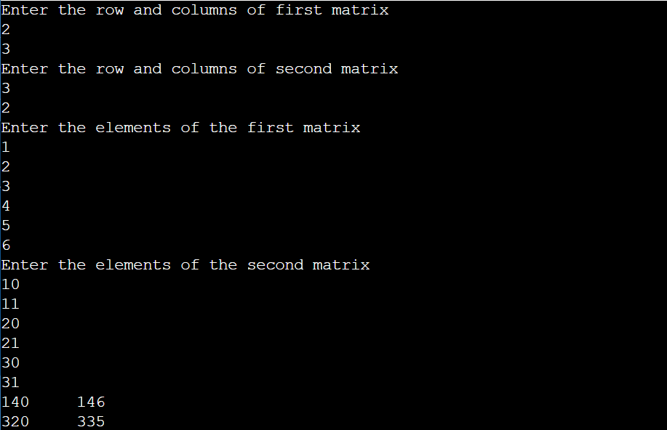

Conclusion: Matrix Multiplication was successfully studied and implemented using C language.